Title : Import Data Using Transform Map

College Name : Balagan Saraswathi Arts and Science
College For Women
College Code : MSU144
University Name :Manonmaniam sundaranar university
Tirunelveli
Course Name : ServiceNow – System Admin with IT Service
Management & AI Emphasis
Department | :B.scInformationTechnology
Team ID | : SWTID-2026-2169
Team Leader | :Muthu Rani P
Team member | :Uthaya lakshmi S
Team member | : Mariya cinterlla A

Import Data Using Transform Map

Introduction:
Import Data Using Transform Map is a process used to import data from external sources into ServiceNow tables. A Transform Map helps to map source fields to the corresponding target table fields. It ensures that data is transferred accurately and efficiently. In this lab, data is imported using a Transform Map to organize and manage records. This process helps maintain data consistency and supports secure access to records through ACLs.

Accessing Tables in ServiceNow
- In Google search Google Spreadsheet create a spreadsheet and import the datas then save.
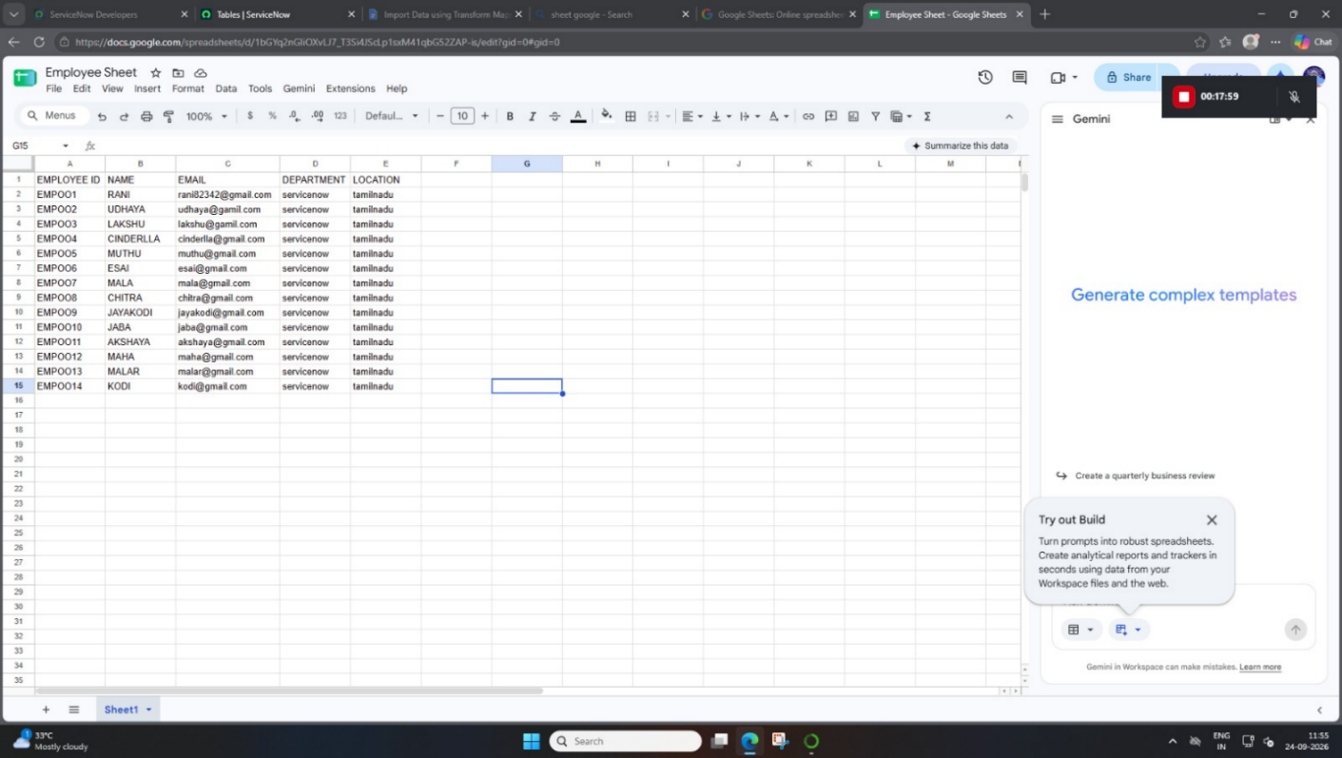
- Log in to the ServiceNow instance with admin access.
- Click the All menu in the navigation bar.
- Enter Tables in the Filter Navigator search box.
- Select Tables under System Definition.
- Open the Tables module to view and manage table records.

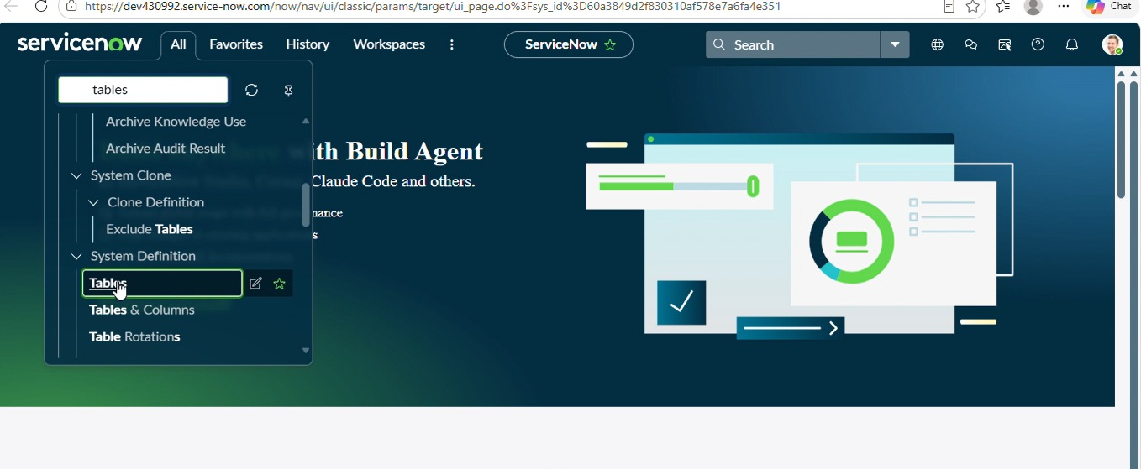

Employee Tests:
1. Log in to the ServiceNow instance with admin access.

Creating an Employee Test Table
- Log in to the ServiceNow instance with admin access.
- Navigate to All → System Definition → Tables.
- Click New to create a new table.
- Enter Employee Test in the Label field and verify the Name field.
- Configure the required columns and click Submit to create the table.
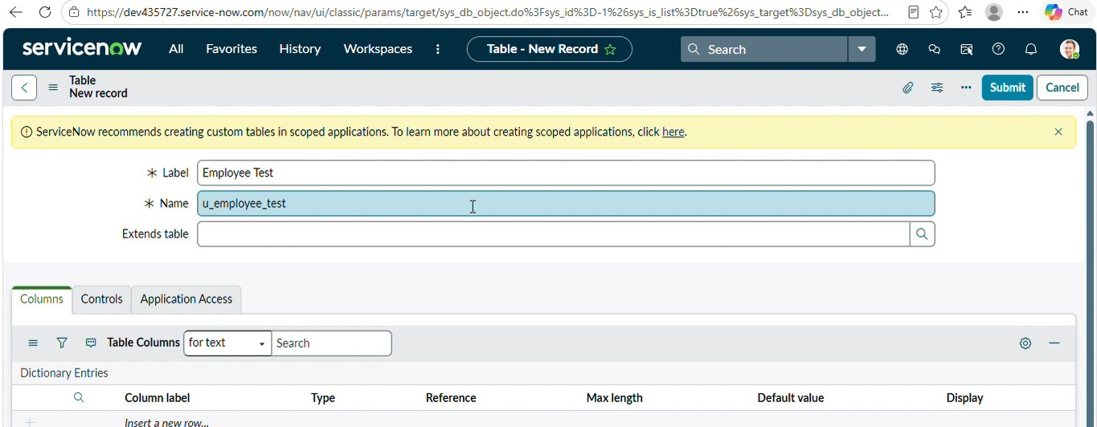

Mapping Fields Using Transform Map
- Open Mapping Assist in the Transform Map.
- Select the required source fields from Employee Import.
- Map the source fields to the corresponding target fields in Employee Test.
- Verify that all fields are mapped correctly.
- Click Save to complete the field mapping.
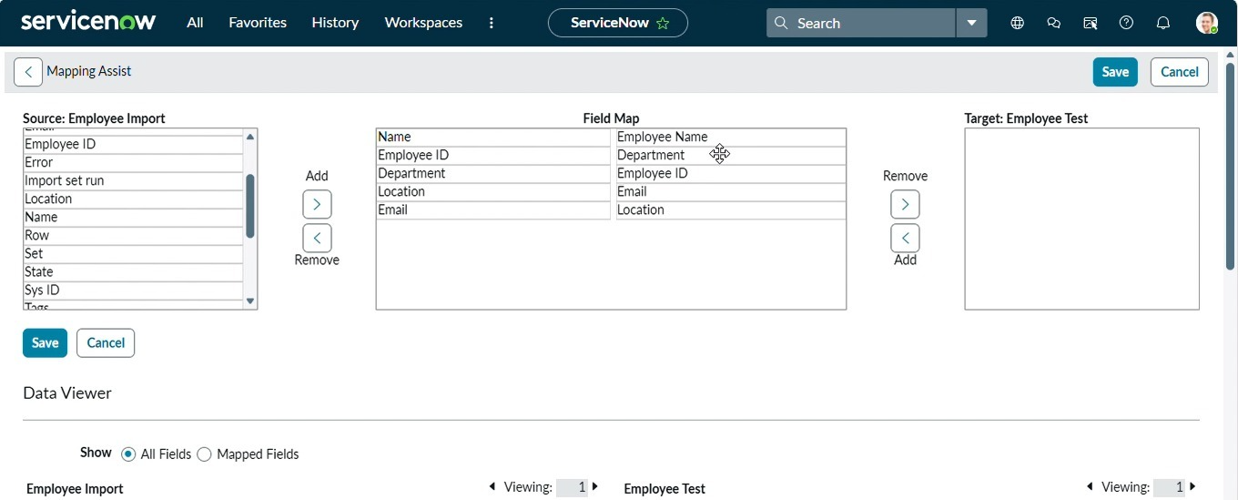

Loading Data :
- Log in to the Service Now instance with admin access.
- Navigate to All → Load Data and select Create table.
- Enter Employee Import in the Label field.
- Select File, upload Sample Sheet 1.xlsx, and enter 1 in the Sheet number and Header row fields.
- Click Submit to import the data and verify the records.

Transforming Imported Data
- Load the data into the ServiceNow import set table.
- Verify that the State is Complete and the Completion code is Success.
- Click Loaded data to view the imported records.
- Click Create transform map to create a Transform Map for the imported data.
- Verify the import status and check the Import log for errors.

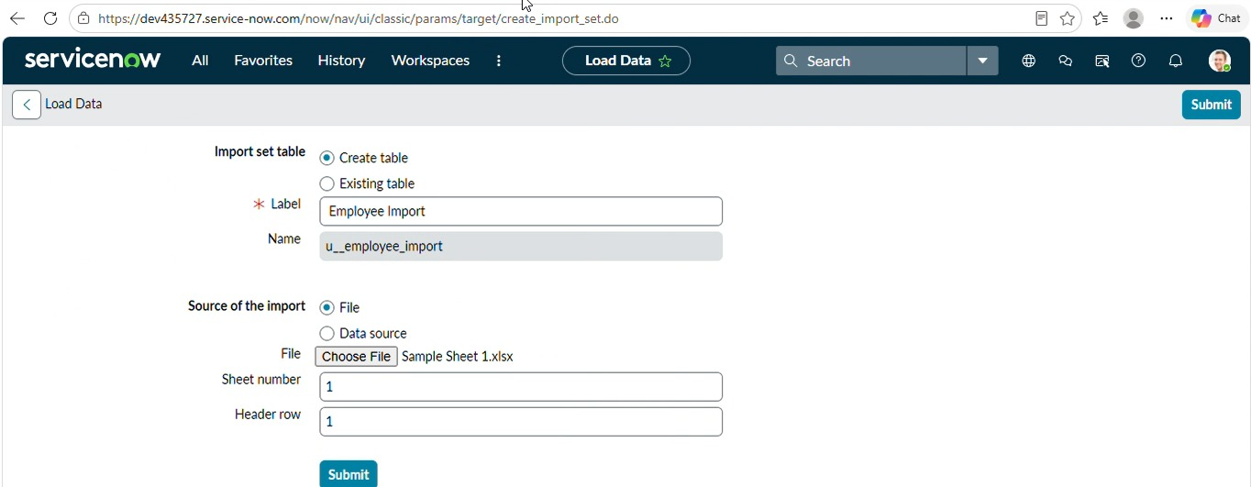

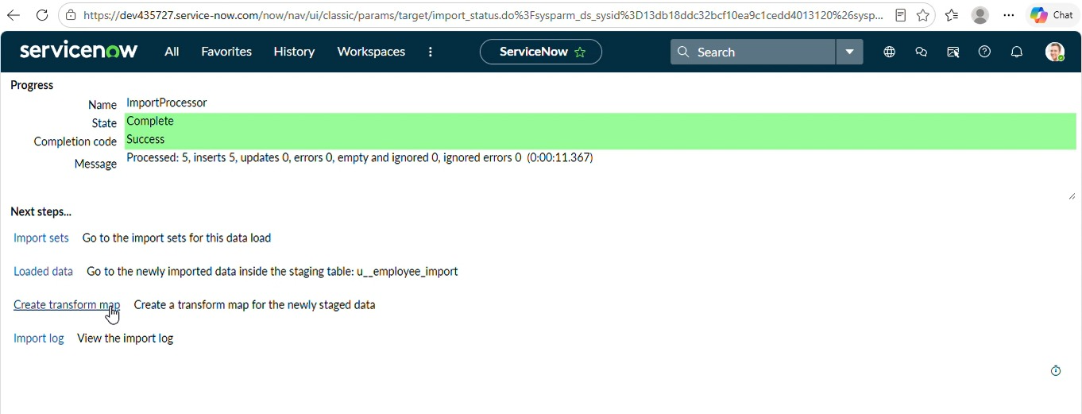

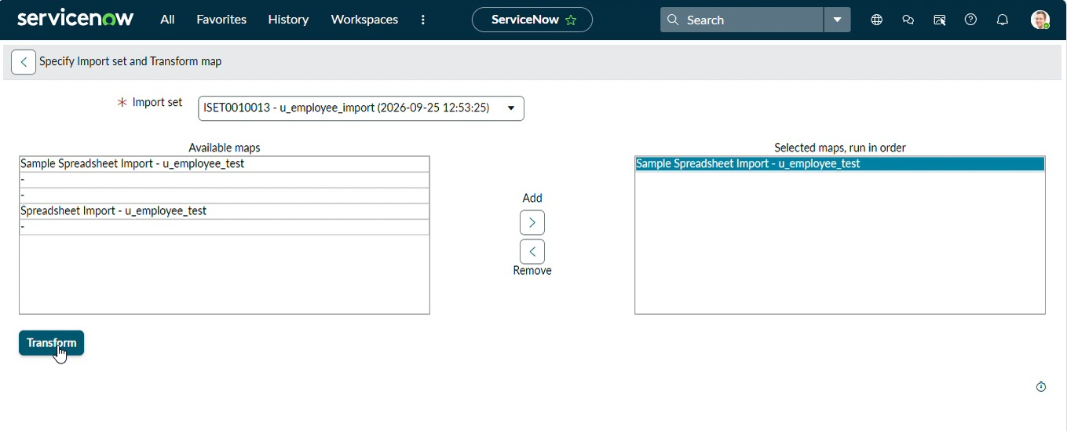

Accessing ACL in ServiceNow
- Log in to the ServiceNow instance with admin access.
- Click the All menu in the navigation bar.
- Search for Access ACL in the Filter Navigator.
- Select Access Control (ACL) under System Security.
- Click New to create a new Access Control List (ACL).
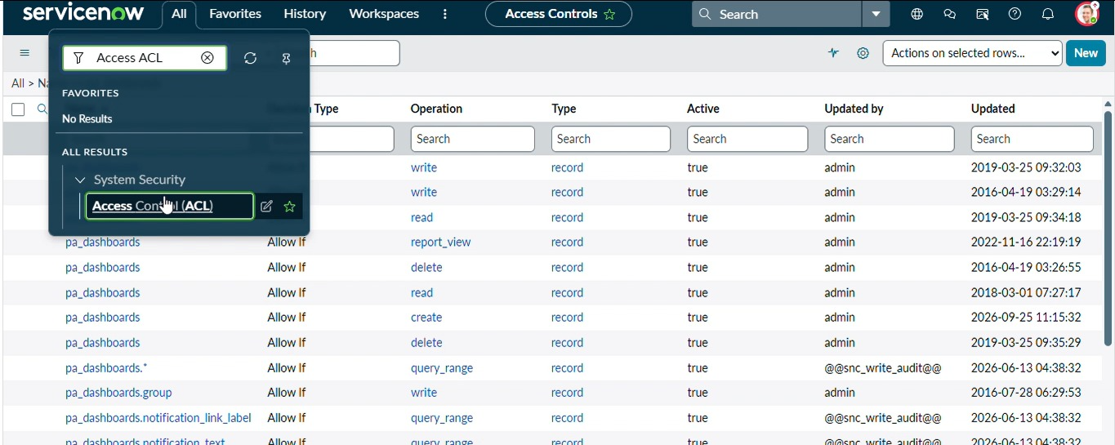

Viewing Access Control Lists
- Log in to the ServiceNow instance with admin access.
- Navigate to All → Access Control (ACL).
- Search for pa_dashboards in the Name field.
- View the available ACL records and their operations, such as Read, Write, Create, and Delete.
- Select the required ACL record to view or modify its settings.

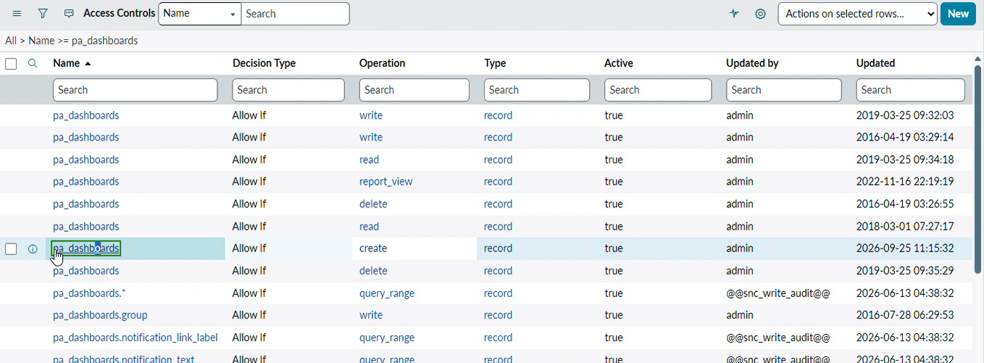

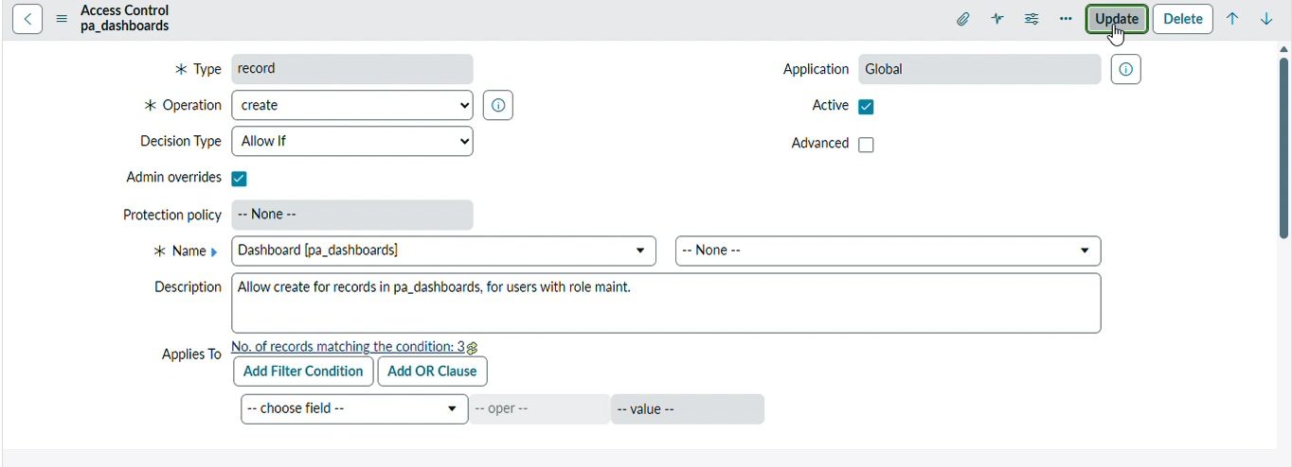

Viewing the Employee Dashboard
- Log in to ServiceNow with admin access.
- Navigate to Employee Analytics Dashboards.
- Dashboard name as Employee Analytics Dashboard
- Open the dashboard to view the Employees by Department report.
- Verify the pie chart and employee department details.
- Confirm that the report is displayed correctly on the dashboard.

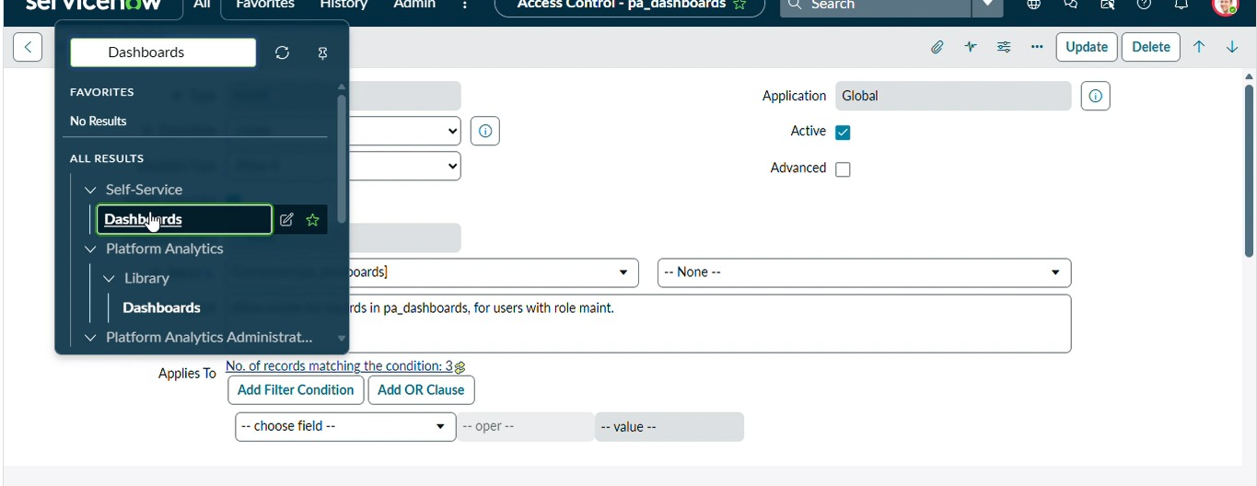

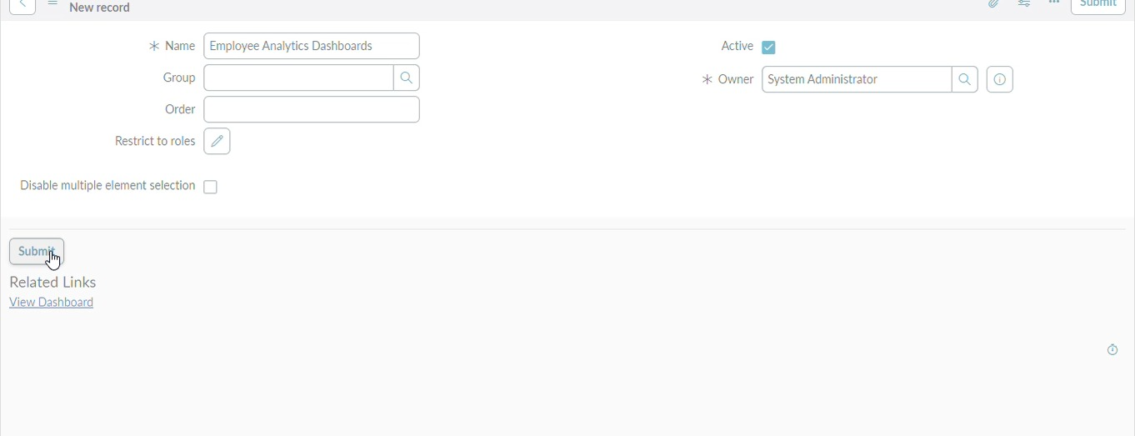

Creating an Employee Report
- Log in to ServiceNow with admin access.
- Navigate to All → Reports.
- Open the Reports module.
- Enter Employees by Department and select the Employee Test table.
- Set Department as Group by and Count as Aggregation, then click Run.

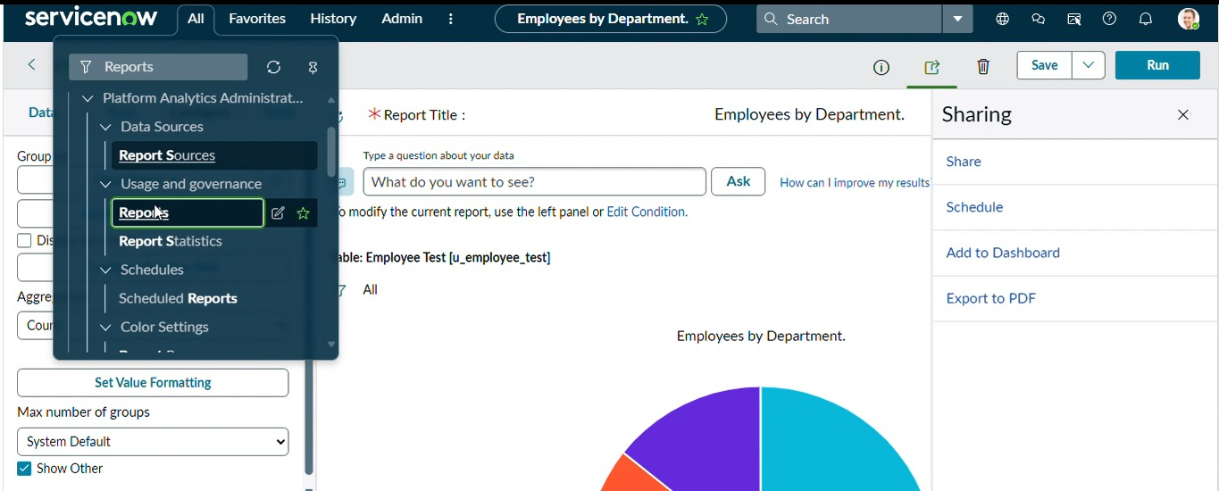

Adding a Report to the Dashboard
- Open the required report in Edit Report.
- Click Sharing and select Add to Dashboard.
- Select Employee Analytics Dashboards in the Dashboard field.
- Select New Tab 1 in the Tab field.
- Click Add to add the report to the dashboard.

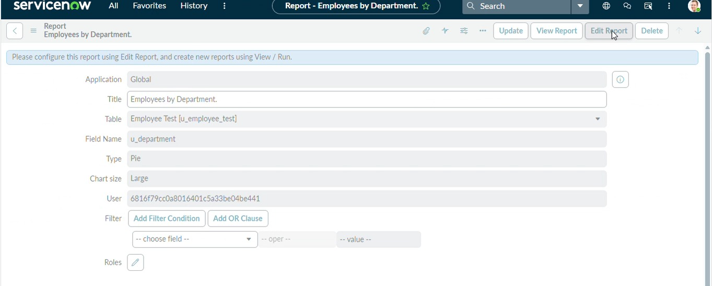
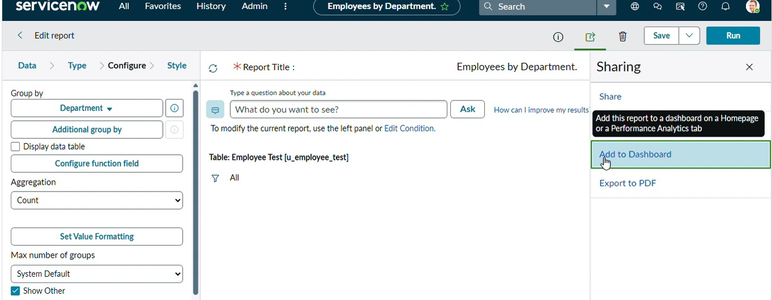

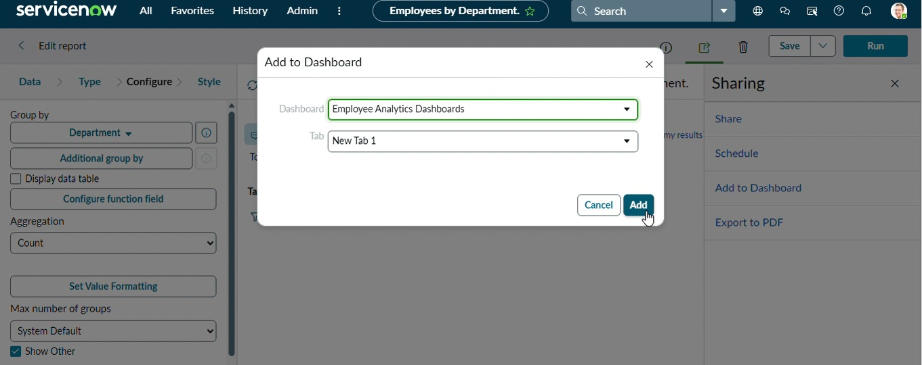

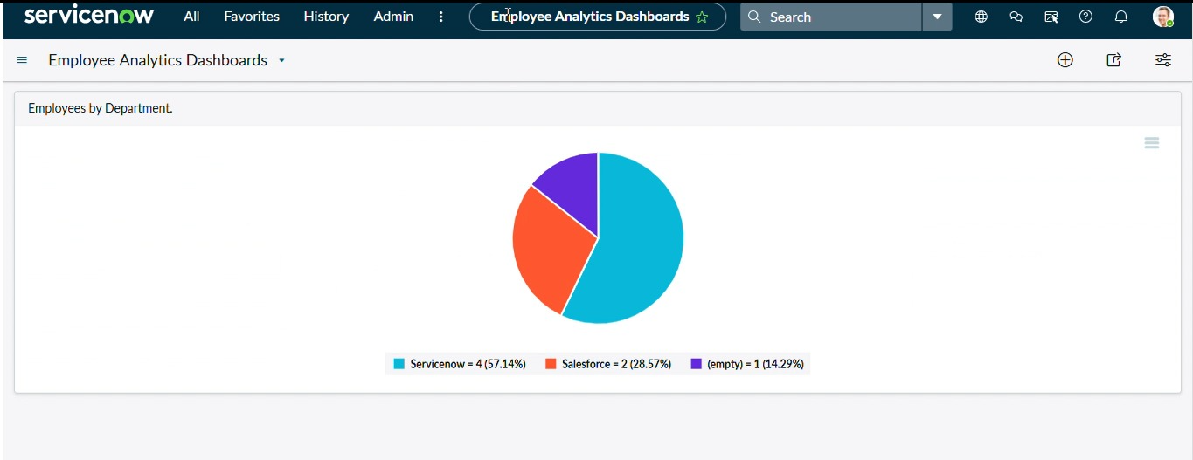

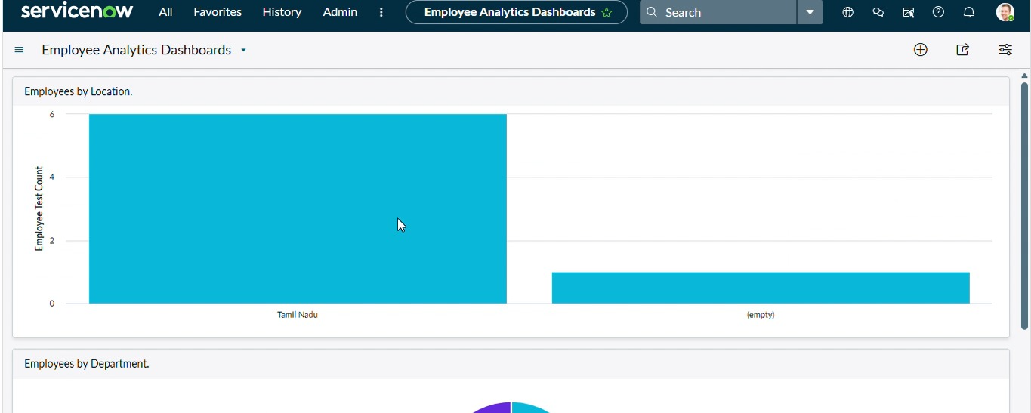

Outcome

By completing this lab, learners gain a clear understanding of how to import data into ServiceNow using Transform Maps. They learn how to upload external data, create import set tables, map source fields to target fields, and transform records accurately. This process helps maintain data consistency, reduce manual data entry, and improve data management in ServiceNow.

Advantages
- Simplifies the process of importing data into ServiceNow.
- Reduces manual data entry and saves time.
- Ensures accurate mapping of source and target fields.
- Helps maintain data consistency and integrity.
- Supports importing large amounts of data efficiently.
- Makes data management easier and more organized.

Disadvantages
- Incorrect field mapping may cause data errors.
- Large data imports may take more processing time.
- Requires proper knowledge of Transform Map configuration.
- Invalid source data may affect the import process.
- Changes in target table structures may require updating Transform Maps.

Future Enhancement
In the future, the Import Data Using Transform Map system can be enhanced with automated data validation and error detection features. Advanced field mapping can be introduced to support different data formats and complex data structures. Scheduled imports can be implemented to update records automatically at regular intervals. Data duplication detection and error logging can also be added to improve data accuracy. In addition, integration with external applications and databases can make the import process more flexible, efficient, and reliable.

Conclusion
The Import Data Using Transform Map provides an effective method for importing and managing data in ServiceNow. It allows users to upload external data, map source fields to target fields, and transform records accurately. In this project, data is imported using Load Data and Transform Maps to ensure proper data organization and consistency. Overall, this lab provides practical knowledge of data importing and transformation and demonstrates how Transform Maps help improve data management in ServiceNow.

